**Neighborhood Fragility Index**

**Methodology Note**

**Introduction:**

It is well established in the research that neighborhood quality has an impact on the trajectory of conflict and post-conflict recovery for countries affected by conflict. According to a Murdoch and Sandler (2004), neighbors within a radius of 800 km they find that `a civil war at home is associated with a decline in economic growth of 0.1648, while and additional civil war in a neighbor is associated with a decline of approximately 0.05 or about 30 % of the home-country effect'. Moreover, Murdoch and Sandler (2002, p. 96) contend that a neighboring civil war affects GDP directly and indirectly. The direct effect is from the collateral damage whereby battles close to the border destroy infrastructure and capital. The indirect effect occurs by increasing the `perceived risk to would-be investors and divert foreign direct investment away from neighbors at peace'. So we can tell that a peaceful neighborhood can help creating a stabilized environment and have the possibility to help pulling fragility states out of fragilities.

The quality of the neighborhood affects the trajectory of FCS countries through two channels: (1) A fragile neighborhood may increase the fragility of the affected country and perpetuate the conflict through illegal flows of weapons and fighters; (2) A stable neighborhood can provide the FCS countries with trading partners during and immediately after the conflict. It can also be a source of investment flows.

To capture this determinant of the investment risk and opportunity, we have developed a Neighborhood Fragility Index (NFI) using the Fragile States Index of the Fund for Peace (FFP). This note describes the method by which this index has been calculated.

**Methodology:**

Fragile States Index from Fund for Peace (FFP), which measures fragility from four prospects: Economic, Security, Political and Cohesion. NFI accounts for the fragility of bordering countries, and non-bordering countries that are within 1000 miles (1609 kilometers) from the capital cities. Unlike Murdoch and Sandler, who use 500 miles in their research, we use 1000 miles instead. This is to account for the fact that precise border geographic data is lacking which the distance between the key population centers of any two countries is available more reliably. Therefore, using 500 miles radius range, we may miss some significant neighboring countries in terms of impact of the target FCS’s risk and opportunity.

Distance is a key element of the NFI. Closer countries have more weight in determining the NFI. Since the indicator is focused on the quality of the neighborhood in terms of fragility, size was deemed irrelevant for the purposes of calculating this index. (Note. The neighborhood market size is part of a data toolkit that assesses FCS countries investment opportunities).

Using We use the distance data from CEPII, If the two countries are bordered and two most important cities are within 1000 miles radius, then we weight it as 1, if the two countries are bordered but two most important cities are farther than 1000 miles, then we weight by distance as follows:

*(max dist of the world[1] - distance between two most important cities)/max dist*

The rationale for this is that while some countries are bordered, the most important cities are not within the 1000 radius, like Kabul (Afghanistan) and Beijing (China) the influence of such neighbor will be less than those who are closer, but border influence cannot be ignored. Neighborhood fragility influence through various channels, destabilizing the border is an important one. Also, If the two countries are not bordered but the two most important cities are no farther than 1000 miles, we use the same method to weight as the described above:

*(max dist - distance between two most important cities)/max dist.*

If two countries are **not** bordered and the distance between the most important cities are farther than 1000 miles, then we do **not** include this country as a neighbor in our calculation.

We then multiply the FSI by weight and calculate the aggregate of the total neighborhood fragility of a country, then divide it by the number of countries involved in each neighborhood to get the neighborhood fragility index. This allows us to compare neighborhoods regardless of the number of countries.

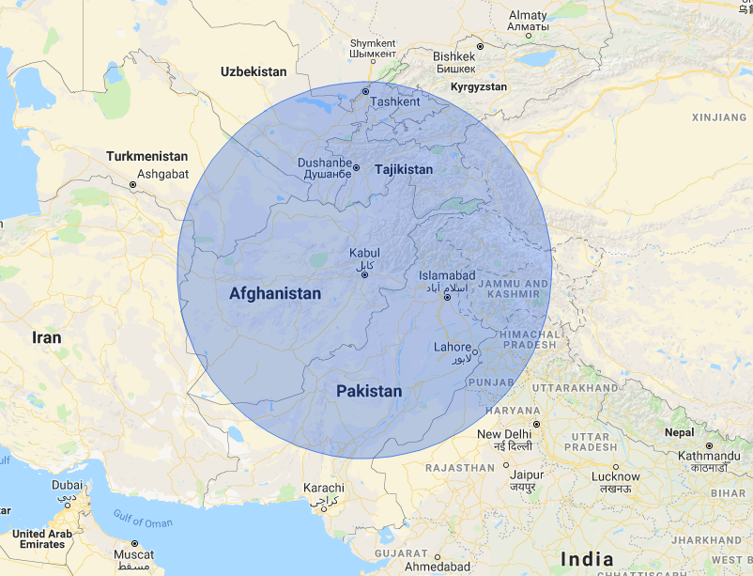

Radius of 500 miles from Kabul, Afghanistan

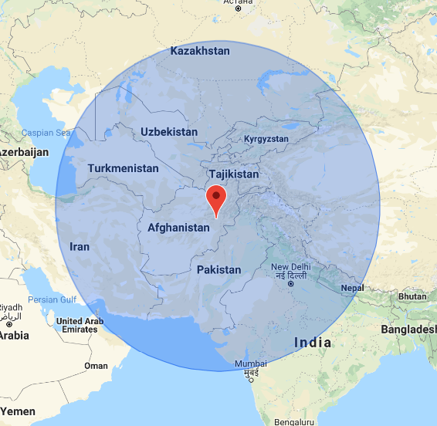

Radius of 1000 miles from Kabul, Afghanistan

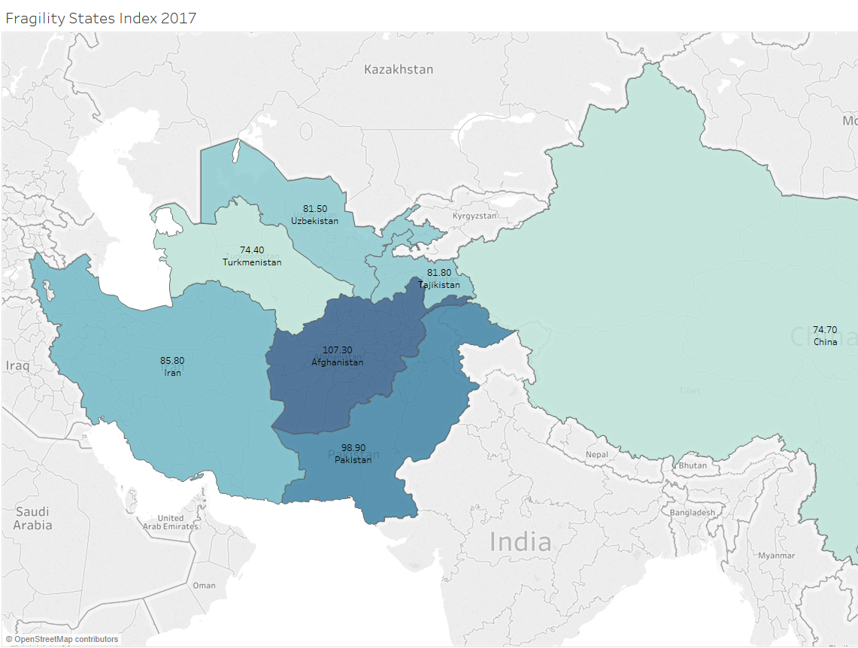

Countries that contribute to Afghanistan’s Neighborhood Fragility Index, radius of 500 miles

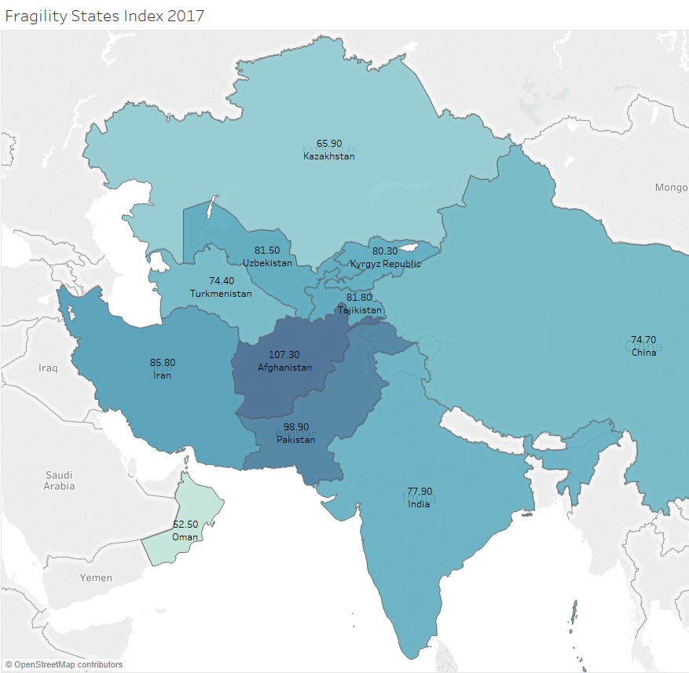

Countries that contribute to Afghanistan’s Neighborhood Fragility Index, radius of 1000 miles

1. This is calculated using the Equator distance of 12756 kilometers. So, the farthest distance on earth is the distance between one point and the point of the earth on the opposite to it, which should be 12756* π/2 = 20036 Kilometers.